**Name: Adithya M SRN: PES1UG20CS621 Section: K**

**Week 7**

1. 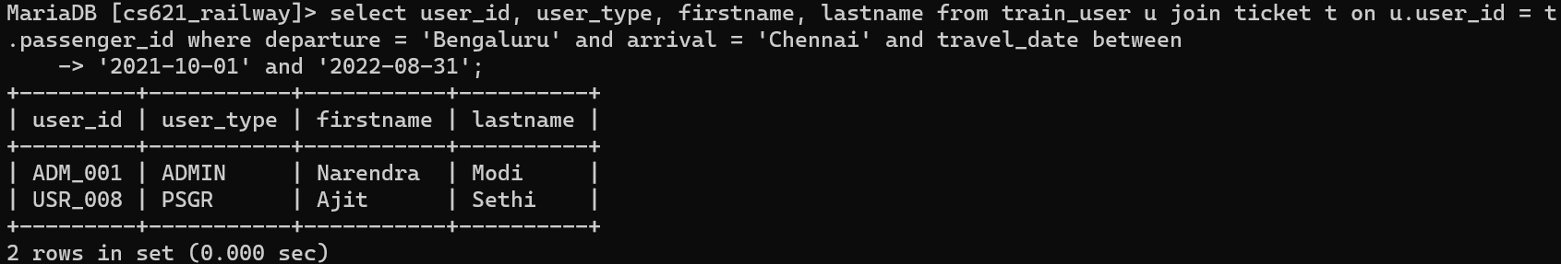
2. 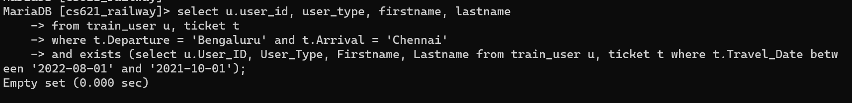
3. 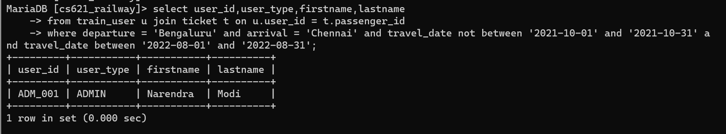
4. 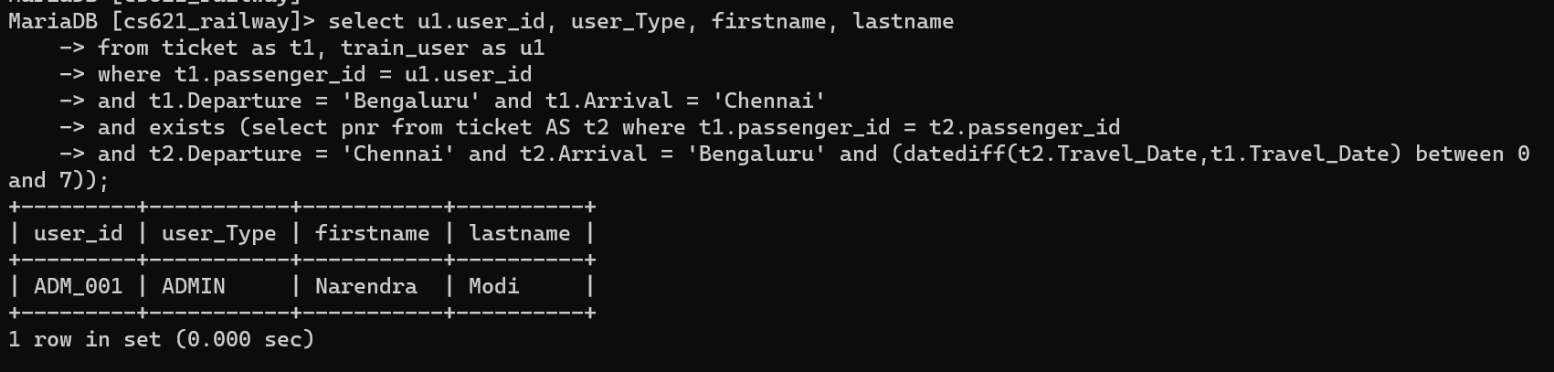
5. 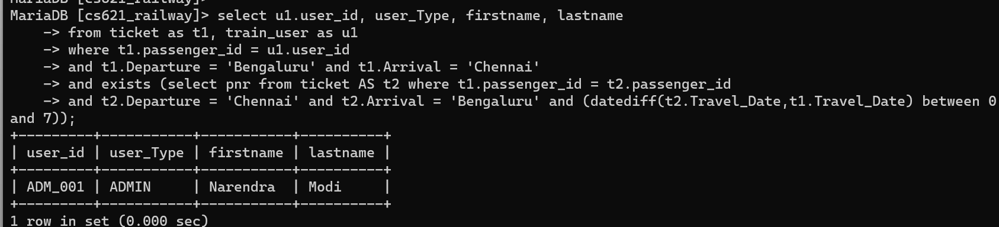
6. 